How to Register with Open Invoice
- Access www.openinvoice.com
- Click on “Login Now”

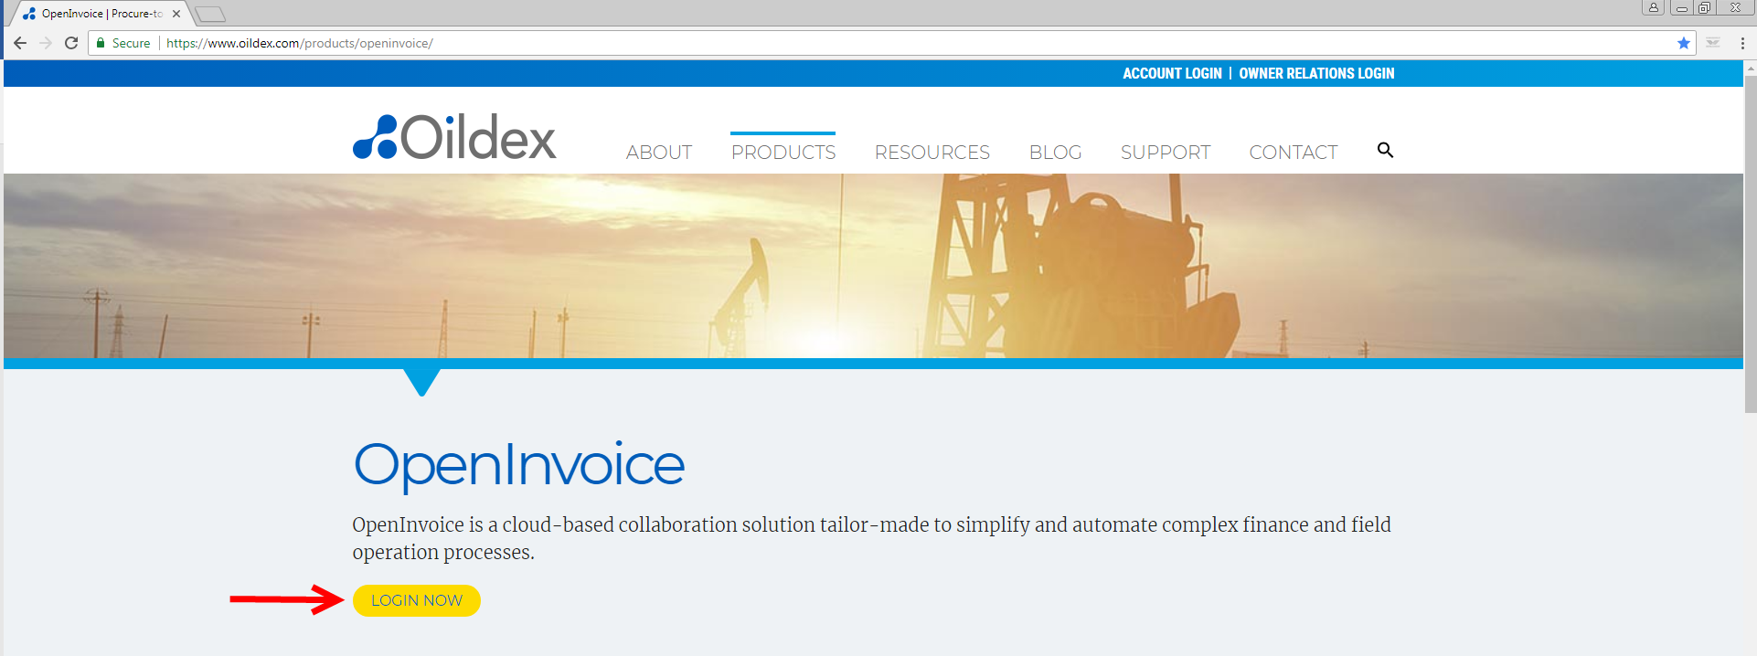

- Click on “Join Now”

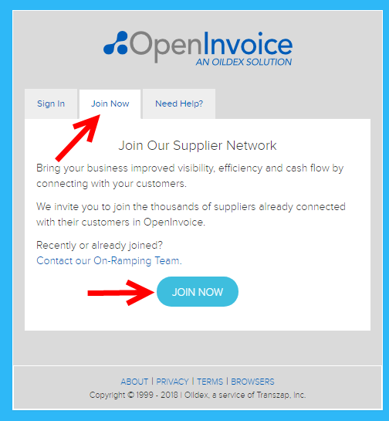

- Complete the registration form

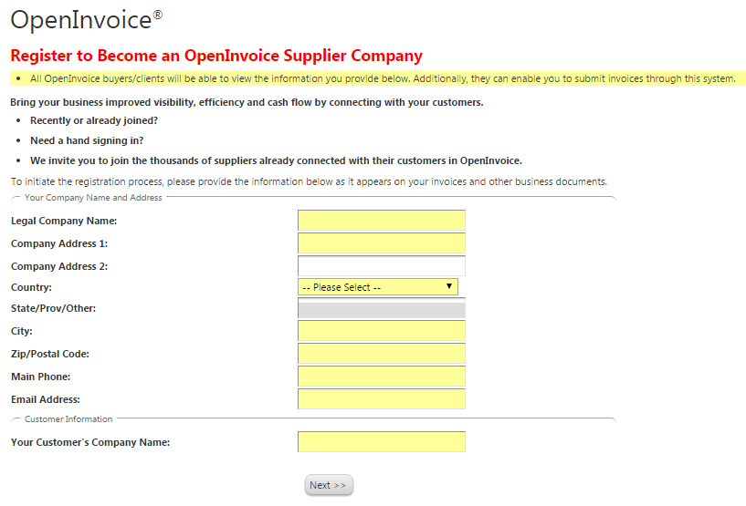

- Once complete, select “Next” and the following information will display on your screen. You will then shortly receive an email to confirm your data. *Please do not forget that step. Once you have completed registration, Hess will have the ability to perform all necessary functions to begin your eCommerce enablement for electronic invoicing.

