How to Register with Open Invoice
- Access www.openinvoice.com
- Click on “Sign In To OpenInvoice”

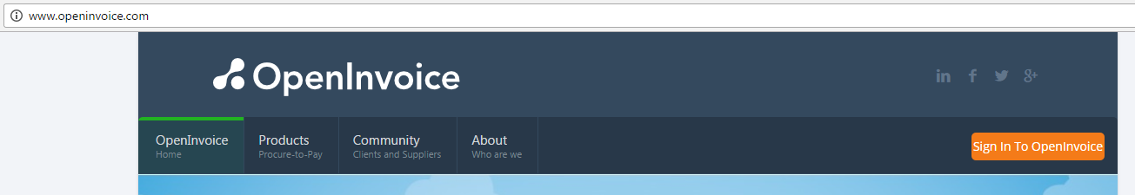

- Click on “Join Now”

- Complete the registration form

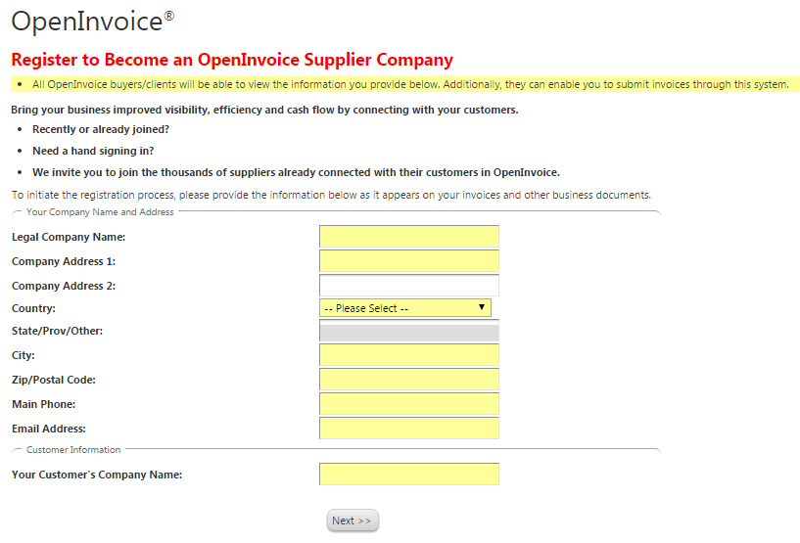

- Once complete, select “Next” and the following information will display on your screen. You will then shortly receive an email to confirm your data. Once you have registered, Hess will have the ability to perform all necessary functions to begin your eCommerce enablement for electronic invoicing.

