**eCommerce**

**Open Invoice Electronic Invoicing Guide**

**for Price Book Invoices**



**Updated May 15, 2018**

Contents

Invoice Requirements 3

Invoice Submission Types 3

Important Information 3

How to Submit a Service Invoice 4

Reviewing Invoice and Invoice Submission 9

Invoice Dashboard 11

Resubmitting a Disputed Invoice 11

How to Submit a Material Invoice 12

How to Create an Invoice from a Purchase Order 14

How to Submit a Credit Invoice 15

Customer Sites (Company Entities by Region) 18

eCommerce Contact Information 18

# Invoice Requirements

In preparation for creating an invoice in Open Invoice, ensure you have received the following information from your Hess Business Partner for every invoice:

* **PO Number**
* **PO Line**
* **Charge Code:** 
  + **Blanket PO (BPO):** (begins in 47) Network Activity or Work Order only
  + **Discrete Service PO:** (begins in 45) Network Activity, Work Order, or Cost Center
  + **Discrete Material PO:** (begins in 45) Network Activity, Work Order, Cost Center, or an AFE
* **Contract Number**
* **Company Entity Name:** “Customer Site” (Refer to the last page of this guide for a list of all US Customer Sites by region)
* **Backup Documentation:** Examples include field tickets, third party charges, etc.

# Invoice Submission Types

* **Direct Entry:** Created by the supplier who manually enters the invoice in Open Invoice
* **Supplier Link:** Created by the supplier who connects their accounting system (QuickBooks or other systems via file import) for invoice creation and submission.
* **LIDO CSV / LIDO XML:** Created by the supplier who uploads a CSV or XML file containing the invoice header and line item details in an Open Invoice template format. Once uploaded, the supplier can modify the invoice content and/or add attachments prior to submitting the invoice.
* **B2B (Business to Business):** Created by the supplier who transmits an XML file containing the invoicing details, including attachments, using an integrated system.

# Important Information

Suppliers should strive to submit invoices for approval via [www.openinvoice.com](http://www.openinvoice.com) within a reasonable time from the completion of the work or delivery of goods. Our goal is to achieve “Real Time Cost” via frequent invoice submission. Refer to your Hess Commercial Agreement or PO Terms and Conditions for invoice frequency expectations.

Invoices will only be accepted by Hess if received within ninety (90) days (or the time frame stated in your Commercial Agreement or PO) from the completion of the work or the delivery of goods.

Confirm the invoice has been submitted by noting the confirmation message when submitted and ensure the invoice status is “Submitted”.

*\*A successful submission is one where there are no errors or disputes.*

**Payment terms begin once a successfully submitted invoice has been approved and will be defined by the submission date in the invoice journal.** *If an invoice is disputed, the payment terms will restart with the new submission date.*

**Please remember to submit any “Saved” invoices at your earliest opportunity.**

# How to Submit a Service Invoice

**Note: All required fields are listed in the instructions.**

1. Go to the Invoice tab and select “Create Invoice” from the drop-down box.
2. Starting with a “Standard Invoice”
   1. **Supplier Site:** Use the drop-down box to select your Supplier Site.
   2. **Customer Name:** Select “Hess E&P” from the drop-down box.
   3. **Customer Site:** Select the Hess site from the drop-down box that matches with the Hess Site listed on the referenced Purchase Order. Refer to the last page of this guide for a list of all US Customer Sites by region.
   4. **Customer Department:** Defaults automatically – **Do not change.**
   5. **Creation Options:** Defaults to “Standard”
   6. Click **“Next”.**

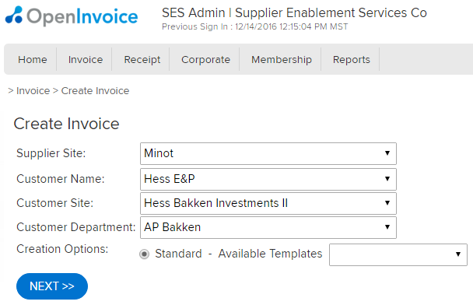

**E**

**F**

**A**

**D**

**C**

**B**

1. Invoice Header Details
2. **Invoice Number:** Enter a unique invoice number up to 16 alpha-numeric characters. **Do not include spaces or special characters.** A dash is acceptable.
3. **Invoice Type**
   * 1. Select “Original Invoice” from the drop-down box for a standard (debit) invoice.
     2. Select “Credit Invoice” from the drop-down box for a credit invoice.
4. **Invoice Date:** The original date from your company generated invoice
5. **Currency:** Select “USD” from the drop-down box.
6. **Description:** Enter an invoice description of the services performed and where the services were performed (Example: Frac Services Rig 24 at RS-Anderson 193-55-24-32H2).
7. **Contract:** Select the applicable contract from the drop-down box. A contract selection is **required** on all invoices.
8. Select the “**Next**” button.

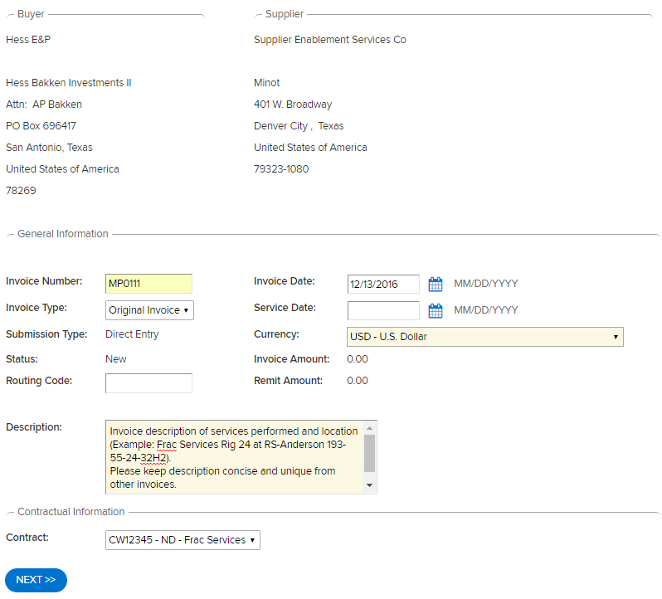

**E**

**A**

**B**

**C**

**D**

**G**

**F**

Confirm all the invoice header details are included and correct, then click “**Add Line Item**” (click “**Edit Header**” if any changes are needed).

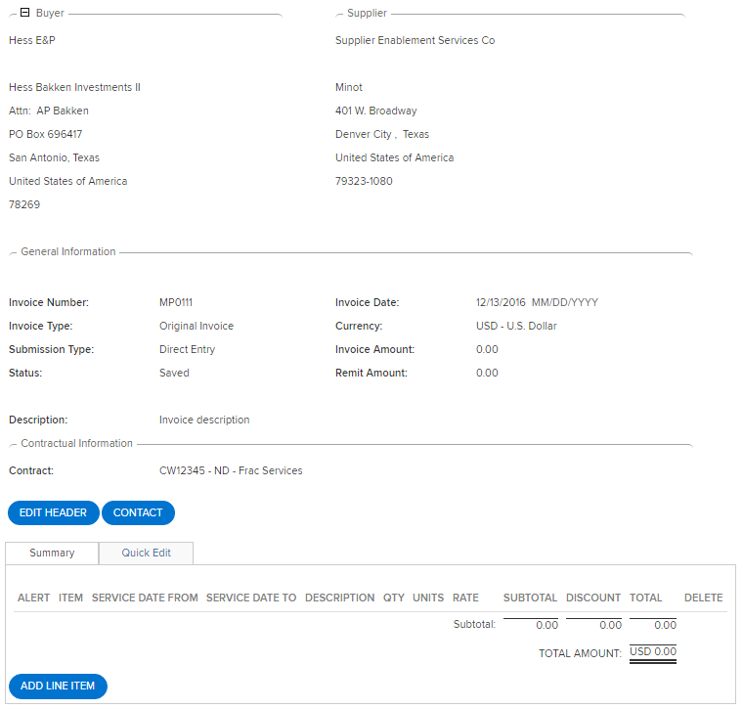

*All fields listed here are required for a successful submission. Please ensure these fields are filled in with the proper information.

1. Adding Line Items

A. **PO**: Select the PO from the drop-down box.

* + 1. Only one PO number can be referenced per service invoice.
    2. A PO is required for all invoices.
    3. If your PO is not available in the drop-down box, it is invalid. Please contact your Hess Business Partner, Hess Contract Manager, or Hess eCommerce team for validation.
    4. When entering your PO, make sure to select the PO number from the drop-down list otherwise the PO Line may not populate for your selection.
  1. **PO Line**: Select the PO line from the drop-down box or enter the PO line number (PO line will always total five digits – add preceding zeros when necessary. For example “00010” for line 10 or “00100” for line 100).
  2. **Service Date From**: Date service started for the invoicing period
  3. **Service Date To**: Date service ended for the invoicing period
  4. **Product/Service:** Click in the Product/Service field. A list of products/services is displayed. To narrow the list, start typing the name of the product/service.
     1. Select the appropriate Product/Service from the list.

**Note**: The Part #/Item ID, Description, and Rate will be automatically populated. The description of the product/service from the buyer’s price book will be displayed by default.

* + 1. An alert will display if the price book description was altered by the supplier.
    2. The Pricing Source table will appear and display the item in the price book and/or your catalog.
    3. Your Price Book should be referenced for most or all of your invoice line items. If something is missing, work with your Hess Contract Manager to have your Price Book updated.
  1. **Description**: This is a free text field to further describe the invoice line item if needed.
  2. **Quantity**: Enter the quantity to be charged
     1. Up to three decimal places are accepted (Example: 5.123)
     2. Quantity charged must be positive (Example: 5)
     3. Quantity for CREDIT line items must be negative (Example: -5). See section in this guide titled “How to Submit a Credit Invoice” for more details on credit invoices.

**Mixed debit and credit invoices are not allowed. Please submit one invoice for your charges/debits and a separate invoice for credits only.**

* 1. **Units**: Unit of Measure will automatically populate if your Price Book and/or catalog contains units. Please contact your Hess Contract Manager for a current list of Hess accepted Units of Measure.
  2. **Rate**: Will automatically populate for Price Book items where a specific price is listed (use Price Book icon in “Pricing Source” if needed). For pricing ranges, enter the rate in the “Rate” field to a maximum of five decimal places (Example: 15.12345).
  3. **Taxes**: Select the appropriate tax box(es) for any applicable taxes and ensure each tax percentage is correct.

**\*Note**: In order to ensure that taxes are automatically included to your invoice, please make sure your company site has been configured with the applicable taxes. Refer to the OpenInvoice Admin Guide for Suppliers.

* 1. **Chrg Code:**
     1. Only one Charge Code can be referenced per Service invoice
        1. **Blanket PO (BPO):** Enter Charge Code provided from Hess Business Partner Network Activity or Work Order only
        2. **Discrete Service PO:** **Auto populated** by PO and PO Line item once both are selected. Network Activity, Work Order, or Cost Center

**Service Charge Code Examples as Input in Open Invoice:**

***Network Activity codes and Work Orders must be entered in Open Invoice with four preceding zeros***

**Network Activity**: 00005_ _ _ _ _ _ _ _ _ _ (16 digits total)

**Work Order**: 00009_ _ _ _ _ _ _ (12 digits total)

**Cost Center**: Input the Cost Center exactly as you receive it (no preceding zeros)

1. Click “**Add Line Item**” and add more invoice line items if needed **OR**
2. Click “**Next**” if there are no more invoice line items to add.

**Note: A single invoice cannot contain more than 80 individual line items.** If your field ticket or company invoice contains more than 80 line items you will need to split the invoice into segments of 80 line items or less (Example: 123a, 123b, 123c).

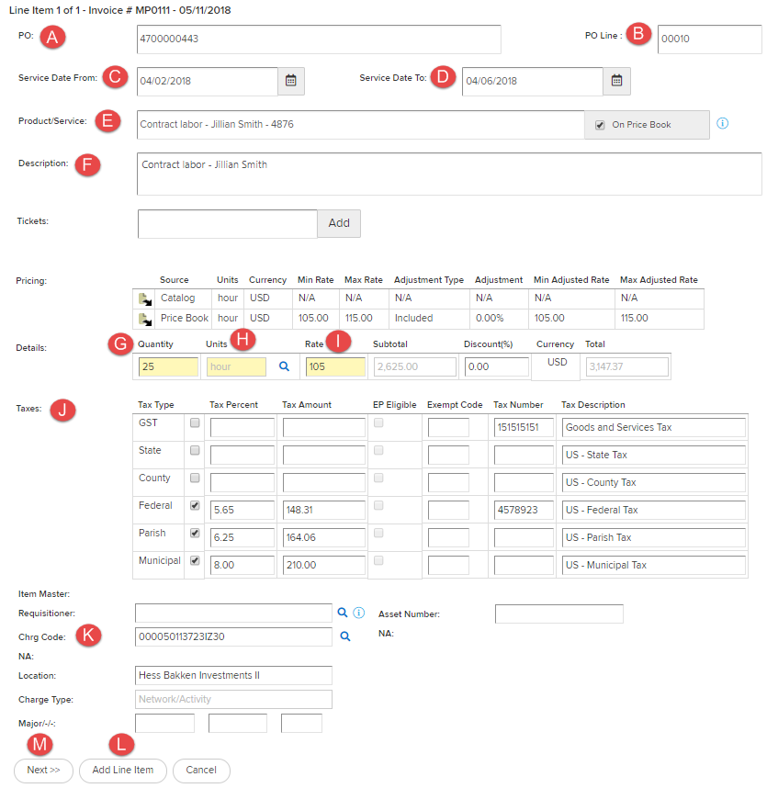

**H**

# Reviewing Invoice and Invoice Submission

* **Total Amount** is accurate (including taxes if applicable)
* **Red Alerts:** Click on the alert to determine the exact cause of the alert and correct if needed. A Red PO alert is acceptable for POs with unlimited funding only.
* Verify that the **same PO, PO Line, and charge code** are referenced on every line for Service invoices
* Check for additional information that should be verified before submitting.

|  |  |  |
| --- | --- | --- |
| **Alert Name** | **Icon** | **Alert Description** |
| On Price Book |  | The invoice or ticket refers to a price book and all of the details on the invoice/ticket match the details on the price book.  **\*Approved Price Book rate. Accepted** |
| Currency Mismatch | cid:image001.jpg@01D3ED21.390AD030 | The currency of a detail invoice line or ticket is different than the currency of the referenced price book.  **\*Hess billing currency should be USD** |
| Above Price Book | cid:image001.jpg@01D3ED21.390AD030 | The adjusted rate (calculated as rate less discount) of a detail invoice line or ticket is greater than the maximum adjusted rate specified on the qualifying price record.  **\*Above negotiated rate. Rejected** |
| Below Price Book | cid:image001.jpg@01D3ED21.13B3CAD0 | The adjusted rate (calculated as rate less discount) of a detail invoice line or ticket is less than the minimum adjusted rate specified on the qualifying price record.  **\*Below Price Book rate (discount) or blank pricing. Accepted** |
| No Price | cid:image001.jpg@01D3ED21.13B3CAD0 | The qualifying price record does not have any rates specified. |
| Off Price Book |  | The referenced price book does not have a qualifying price record.  **\*Item invoiced from Catalog. Accepted, but requires review from Hess Technical Reviewer.** |
| Purchase Order Compliant |  | The invoice line or ticket refers to a purchase order and all of the details on the invoice or ticket match the details on the purchase order.  **\*Acceptable** |
| Amount Overfulfillment |  | The total dollar value of all invoice lines or tickets referring to the purchase order line is greater than the dollar amount of the purchase order line.  **\*Acceptable for BPO (47 series) where limit in $1.00**  **\*Auto-rejected for PO (45 series). Please contact your Hess Contract Manager for PO increase** |

* 1. **Click the “Attach File” button** to attach required backup documentation.
  2. Backup documentation is required on every invoice and is generally at minimum your company generated invoice along with a copy of your field ticket containing PO and charge code data.
  3. Additional backup documentation may be required at the discretion of business requirements (Examples: signatures, third party charges, HAR documents).
  4. File size limitation of 9MB per attachment. Multiple attachments are accepted up to 40MB for B2B suppliers, 80MB maximum for web-based (Open Invoice Direct Entry) suppliers.

1. **Click the “Submit” button** if the invoice is ready to submit.



1. A **comment box** will generate. Please provide comments where appropriate and click the “Submit” button again.
   1. Text confirmation will indicate the invoice has been submitted.
   2. Status of invoice will immediately change to “Submitted” and can be viewed in the Invoice Dashboard.

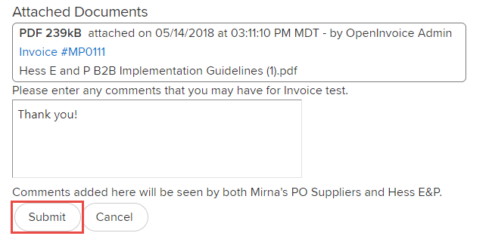

**Click “Submit” when you are finished reviewing the invoice and have attached backup documentation.**

**\*Note: All invoices under the “SAVED” status will not be visible to Hess. Please ensure that you have properly submitted the invoice and the status has changed to “SUBMITTED”.**

# Invoice Dashboard

Invoices can be viewed by status on the “**Home**” tab or individually by using the quick search box in the upper right-hand corner of the Open Invoice portal screen.

**Note:** The “Home” tab only shows invoices submitted under the user’s ID. To view other or all invoices, use “Invoice Search” or “Reports” by selecting these options from the “Invoice” tab.

1. The “Home” tab shows the dollar value of invoices in each status.
   1. **Disputed:** Disputed back for correction. Payment terms will start over when the invoice is successfully resubmitted.
   2. **Unapproved:** Submitted and waiting on approval and payment.
   3. **Approved:** Invoice is approved and will be paid according to payment terms derived from the invoice submission date in the Invoice Journal.
   4. **Paid:** Invoice has been paid.
2. Unsubmitted or Saved invoices can be found by going to the “Invoice” tab and selecting “Unsubmitted Invoices”. Unsubmitted invoices have **not** made it to Hess for processing and are not viewable to Hess until they are submitted.

# Resubmitting a Disputed Invoice

Disputes can occur and should be monitored. Email notification of invoice disputes can be set up within Open Invoice to ensure immediate notification of any disputes. Correct and resubmit any disputed invoice as soon as possible to prevent payment delays.

1. From your invoice dashboard click into **“Disputed Invoices”.**

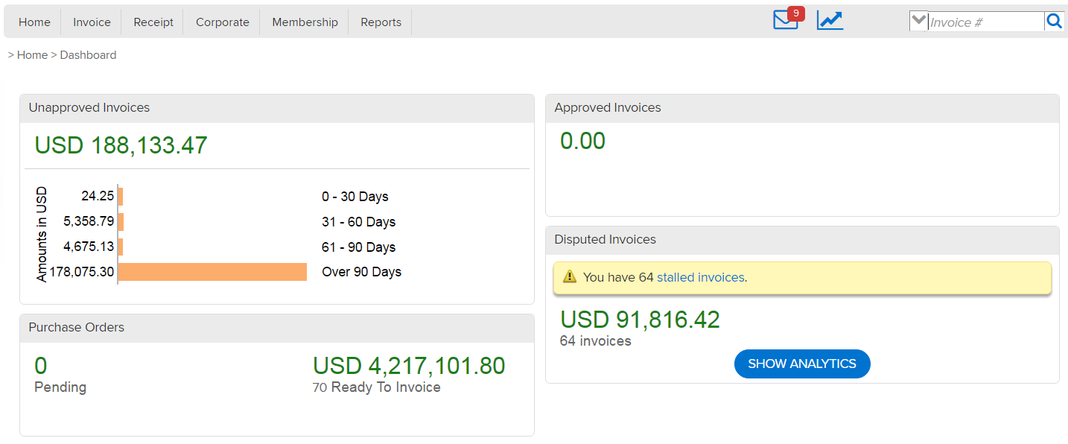

1. Select the blue hyperlinked **invoice number** you wish to update.

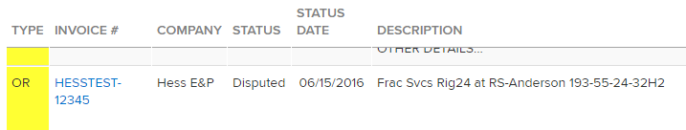

1. Read the **Invoice Journal** to determine why your invoice was disputed. Common dispute messages can be found on the Hess Supplier Network website FAQ guide “Why Was My eInvoice Rejected?” section at <http://suppliers.hess.com/faq>

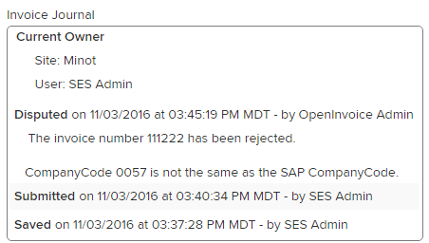

1. Click into the description of each individual invoice line and **make the necessary changes**.
2. Once the changes are complete, click “**Submit**” and you will be directed back to the invoice Header page.
3. Review the Header data, ensure all changes are complete, and click “**Submit**”.

# How to Submit a Material Invoice

The overall system requirements for submitting an invoice do not change based on whether you are submitting a service or material invoice; however, there are a few important differences to keep in mind when submitting a material invoice.

1. Speak with your Hess Contract Manager to understand if your items are true materials or if they are items purchased as part of your service.
2. All material invoices must reference a Discrete PO (beginning in numbers 45).
3. Your invoice may reference one PO, multiple PO lines, and multiple charge codes.
4. Available Charge Codes:

**Material Charge Code Examples as Input in Open Invoice:**

***Network Activity codes and Work Orders must be entered in Open Invoice with four preceding zeros***

**Network Activity**: 00005_ _ _ _ _ _ _ _ _ _ (16 digits total)

**Work Order**: 00009_ _ _ _ _ _ _ (12 digits total)

**Cost Center**: Input the Cost Center exactly as you receive it (no preceding zeros)

**AFE:** For ANY AFE, input **PROJECTINVENTORY** in the Charge Code field

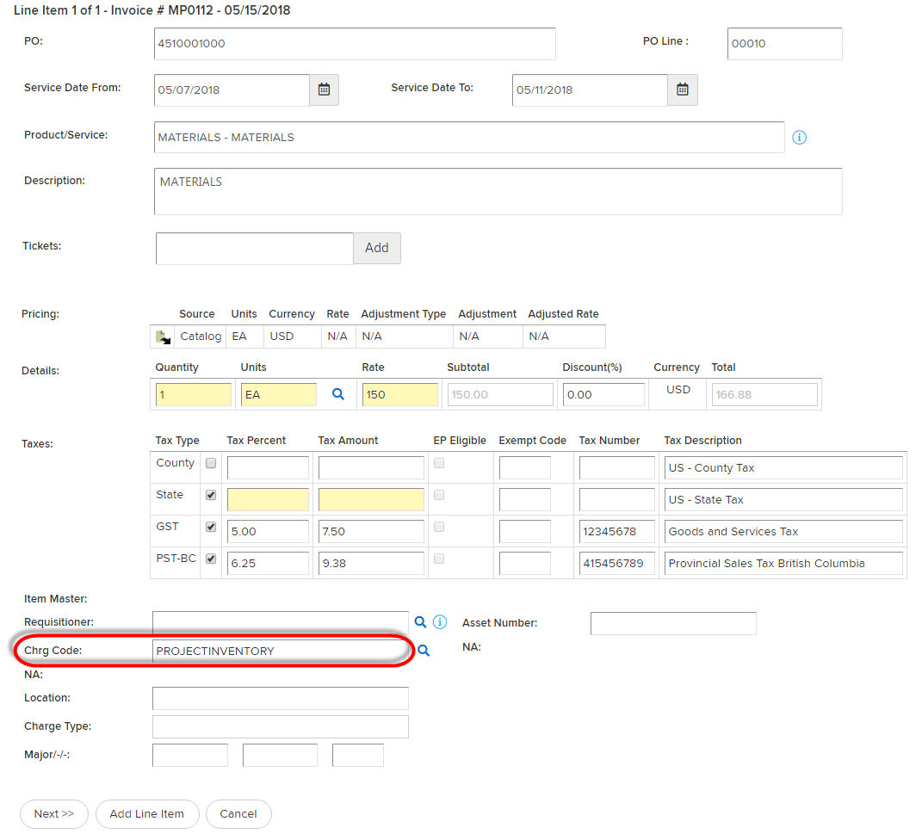

# How to Create an Invoice from a Purchase Order

1. Go to “**Invoice**” tab > Purchase Order Search.
2. Key in the **PO number**. If this field is left blank and you click “**Apply Filter**”, all POs will be visible. Select the correct PO.
3. 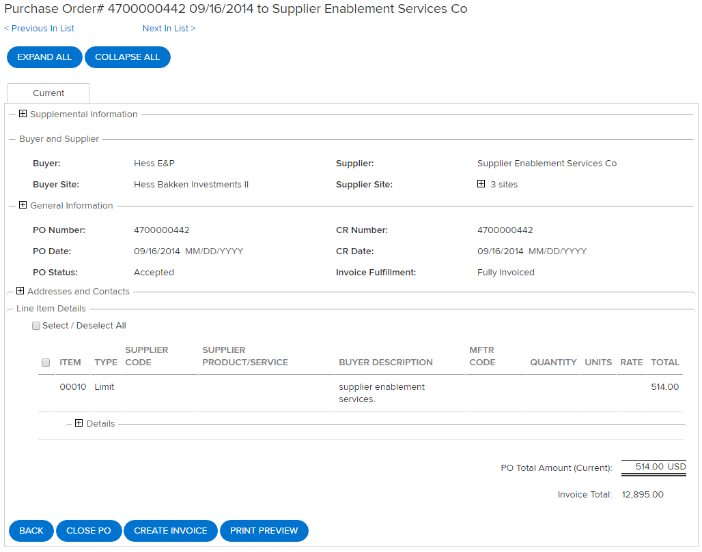Click **“Create Invoice”** button.
4. Once you are in the “Create Invoice” function, you will notice some of the data from the PO has been auto-populated for you.
5. From this point, follow the eInvoice guidelines and ensure all mandated fields are filled in and backup documentation is attached before you submit the invoice.

# How to Submit a Credit Invoice

Important information: A Credit Invoice must reference the Original Invoice to which the credit applies. The Original Invoice must have been previously submitted and **Approved** or **Paid** (Submitting a Credit Invoice against an invoice that has not been approved may not be required if the Original Invoice gets disputed).

Credit Invoices are used to credit funds previously charged in error or as compensation for other considerations.

**Important Notes:**

* Ensure Invoice Type selected is “**Credit Invoice**”.
* **Quantity** in a Credit Invoice must be **negative** (Example: -25).

**High-level Steps**

1. Create credit invoice from the “**Invoice**” tab using “**Create Invoice**” selection.
2. Select Customer fields as required ensuring the radio button selected is “**Standard Invoice**”.
3. Complete all required Invoice Header fields (shaded yellow).
4. Ensure the “**Invoice Type**” selected is “**Credit Invoice**” and “**Service Date**” is entered.
5. Before adding line items, select the Original Invoice to be credited.
6. Add first line item details including PO, PO Line, Product/Service selection, and confirm Rate.
7. Enter the **quantity** as a **negative** number (credit).
8. Select taxes to be applied, if any.
9. Click “**Add Line Item**” until all line items are included, then click “**Next**”.
10. Verify Credit Invoice details, “**Save**” or “**Attach File**”, then “**Submit**”.
11. On the last page, enter a comment if desired and click “**Submit**”.
12. Note the confirmation message that the Credit Invoice has been “**Submitted**”.

**Detailed Step Instructions**

1. Navigate to the Invoice Tab ‘Create Invoice’ - **hover over the Invoice Tab and select “Create Invoice”** from the drop-down
2. STARTING WITH A “STANDARD INVOICE”
   1. **Supplier Site:** If prompted, **use the drop-down box to select the site** for invoicing.
   2. **Customer Name:** Select “Hess E&P” from the drop-down box.
   3. **Customer Site**: Select appropriate site from the drop-down box.
   4. **Customer Department**: Defaults based on your Customer Site selection.
3. SELECTING “CREDIT INVOICE” AND OTHER HEADER INFORMATION
   1. **Invoice Number**: Enter a unique Invoice number up to 16 alpha-numeric characters. **DO NOT include spaces or special characters.** A dash is acceptable. Suppliers often append the original invoice number with “CM” to indicate it is a Credit Invoice (e.g. “CM12345” or “12345CM”).
   2. **Invoice Type: Select “Credit Invoice” from the drop-down box – VERY IMPORTANT**
   3. **Service Date**: Enter the original date the service was provided (start date).
   4. **Currency**: Select “USD” from the drop-down box if required.
   5. **Invoice Description**: Enter a description of the Credit Invoice. This is required and is usually where an ‘explanation’ is provided (e.g. Credit Invoice to compensate for over-charge on Invoice 12345).
   6. Confirm all the Header Level details are included and click the “NEXT” button.
4. SELECTING THE ORIGINAL INVOICE TO WHICH THIS CREDIT APPLIES
   1. Click the “**Original Invoice**” button to ‘search’ for the invoice number.
   2. Enter the Original Invoice in the search box and click “**Apply Filter**” (using an asterisk “*” will pull up all invoices).
   3. Select the radio button for the Original Invoice.
   4. Scroll to the bottom and click the “**Next**” button.
   5. Ensure the Original Invoice now appears in the Invoice Header “**General Information**” section (the Invoice number will now be a blue hyperlink to view the original invoice if needed).
   6. Click the “**Add Line Item**” button.
5. ADDING LINE ITEMS
   1. **PO**: Enter the PO number and select the PO from the drop-down box that appears. The more digits typed, the smaller the selection will appear in the drop-down box. If the PO number does not appear, click on the magnifying glass icon to the right to search.
      1. Once the PO has been selected, the letters “PO” to the left become a blue hyperlink directly to the Purchase Order – this is very helpful to verify information if needed.
      2. Only one PO number can be referenced per Credit Invoice.
6. **PO Line**: PO Line will automatically populate if there is only one PO Line number on the Purchase Order or if there are multiple PO lines a drop-down box will appear. The more digits typed, the smaller the selection will appear in the drop-down box. If the PO Line number does not appear, click on the magnifying glass icon to the right to search. To confirm correct selection, click on the PO hyperlink to view the Purchase Order details.
7. **Product/Service Source**: Select the “Price Book” radio button. NOTE: This should ‘mirror’ what is being credited on the original invoice
8. **Charge Type**: This auto-populates once the Product/Service is selected
9. **Description**: Once the Product/Service is selected from the drop-down list, the Description is automatically populated
10. **Pricing Source:** Select the “Price Book” radio button. Enter the **“Rate”** into the **“Rate”** field and “**Units**”.
11. **Quantity: Enter the quantity to be CREDITED into the “Quantity” field.** 
    * 1. **QUANTITY MUST BE A NEGATIVE AMOUNT (e.g. “-25”) – VERY IMPORTANT**
      2. Quantity *can be up to THREE decimal places (e.g. 5.123 NOT 5.1234).*
12. **SELECT TAXES** (if applicable)
    * 1. Select all taxes to be credited back that apply – **check the small boxes on the left** for EACH tax that is to be credited back – ensure the tax rate at the column heading is accurate for each tax selected.
13. **Click the “Add Line Item” button** to add more Credit Line Items

**OR**

1. **Click the “Next” button** if there are no more Credit Line Items to add.
2. CREDIT INVOICE SUMMARY AND SUBMISSION
   1. **Review the Credit Invoice to verify the following:**
      1. **“Credit Amount”**, including totals and taxes, matches expectations.
      2. **PO Alerts are green**
         1. Click on the PO Alert if not green to determine exact cause of Alert and correct if needed.
      3. Same **Purchase Order** is on every line.
3. **Click the “Submit” button** if the Credit Invoice is ready to submit.
   * 1. On the final screen, enter any comments in the “Comments” box if applicable (not required).
     2. **Click the “Submit” button at the bottom of the “Comments” box.**
     3. Text confirmation will indicate the Credit Invoice has been submitted.
     4. Status will change to “Submitted” and can be viewed by navigating to the Invoice “Dashboard” and clicking on the blue-hyperlink number next to “Submitted” in the Invoice table.
4. VIEWING THE CREDIT INVOICE
   1. The Credit Invoice can be viewed on the **“Invoice”** tab by typing the Credit Invoice into the search box for “Invoice #”.

**NOTE: The “Invoices” table only shows Invoices submitted under the user’s login ID. To view other or ALL invoices, use “Invoice Search” or “Reports” by selecting these options when hovering over the “Invoice” tab.**

Disputes can occur and should be monitored. Correct and resubmit any Disputed Invoices as soon as possible.

Email notification of Invoice Disputes can be set-up to ensure immediate notification of any Disputes. **Correct and resubmit any disputed invoices as soon as possible to prevent payment delays.**

# Customer Sites (Company Entities by Region)

|  |  |  |
| --- | --- | --- |
| **Region** | **Company Code** | **Company Name (Buyer Site)** |
| **Gulf of Mexico** | **0032** | Hess Corp/ Stampede |
|  | **0033** | Hess Corp/ Tubular Bells |
|  | **0038** | Hess Corp/ Baldpate-PennSt |
|  | **0039** | Hess Corp/ GOM Deepwater |
|  | **0084** | Hess Corp/ Llano |
|  | **0085** | Hess Corp/ Shenzi |
|  | **0089** | Hess Corp/ Conger |
|  | **2537** | Hess Corp/ GOM Explrtn |
| **New York/New Jersey/Corporate** | **0056** | HessCorp Head Office |
|  | **0440** | Port Reading |
|  | **0590** | Marketing Division |
| **North Dakota** | **0051** | Tioga Gas Plant LLC |
|  | **0052** | Solar Gas, Inc. |
|  | **0053** | Hess Mentor Storage LLC |
|  | **0054** | Hess ND Exp Logistics LLC |
|  | **0055** | Hess ND Pipeline LLC |
|  | **0057** | Hess Bakken Investments II |
|  | **0061** | Hess Trading Corporation |
|  | **2548** | Hess Bakken Inv II LLC Wa |
|  | **2566** | Hess Infrastructure Partners LP |
| **Ohio** | **0193** | Hess Ohio Development |
|  | **0195** | Hess Ohio Resources LLC |

# eCommerce Contact Information

(Monitored during regular business hours M-F 8-5 CST)

[eCommerceProject@Hess.com](mailto:eCommerceProject@Hess.com)

**Note that when you send an email to** [**eCommerceProject@hess.com**](mailto:eCommerceProject@hess.com) **you will receive an INC that looks like INC1xxxxxx. The same INC number will be used to communicate back and forth with you until the issue has been resolved.**

**Do you have eInvoice questions? Visit the Hess Supplier Network site at:** [http://suppliers.hess.com](http://suppliers.hess.com/faq)